ASSIGNMENT NO 10
1)write a query that produces all pairs of salespeople who are living in the same city include combinations of salespeople with themselves as well as duplicate rows with the orders reversed.

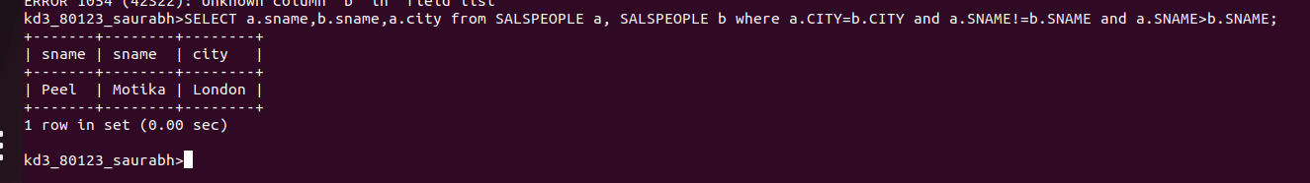

2)write a query that produces the names and cities of all customers with the same rating as Hoffman;
ans;
